BTT Writer for Android

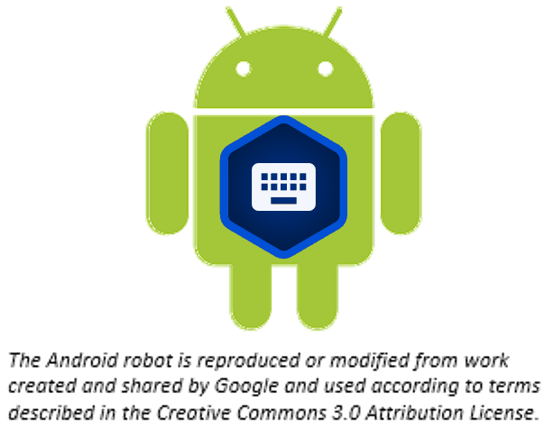

Table of Contents

Introduction to BTT Writer for Android 3

How do I install BTT Writer on an Android device? 3

Choosing What to Translate 4

How do I use BTT Writer for the first time? 6

Login Options 7

Logging Out 11

How do I Start a New Project? 13

How do I navigate in BTT Writer? 18

Layout 18

Working Views Icons 20

Slider 22

Options Menu 23

How do I translate in BTT Writer? 23

Translate Text 24

Check and Edit Translated Text 26

Using the Resources 29

How Do I Translate Footnotes? 31

Uploading/Exporting Your Work 33

Importing a Project 38

Importing Duplicate Projects 44

Resolving Merge Conflicts 45

Publishing Content 46

Self-Publishing 47

Source Text Publishing 47

Modifying Program Settings 51

General Settings 52

Server Settings 55

Advanced Settings 56

Updating Program Elements 57

Updating List of Available Source Texts 58

Downloading Available Source Texts 59

Updating List of Available Target Languages 62

Checking for Updates to BTT Writer 62

## [Introduction to BTT Writer for Android](http://help.door43.org/en/knowledgebase/9-translationstudio/docs/10-introduction-to-the-translationstudio-android-program)

BTT Writer-Android is a mobile app where translators can do offline translating. It can be downloaded for Android devices: see <https://bibletranslationtools.org/downloads/>.

It contains the content that needs to be translated as well as translation resources (See: Using the Resources). You can share information directly from device to device, and you can upload finished content to the server where it can be digitally published.

## How do I install BTT Writer on an Android device?

**Note:** This process requires an Internet connection.

1. In the browser on the Android device, go to this URL: <https://writer.bibletranslationtools.org/download/>
2. Tap on the **Download APK** button to download the install program to the tablet.  
   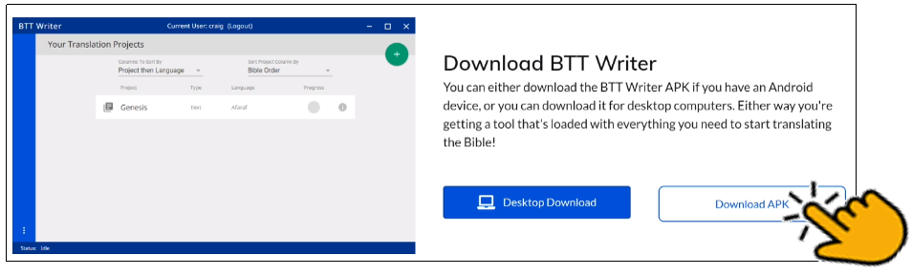
3. Tap **Open** on the download message (or use the file manager to navigate to the release.apk file and tap it).  
   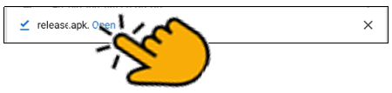 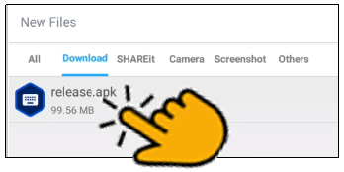
4. On the permissions window, tap **INSTALL**.  
   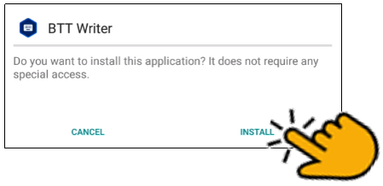
5. Once the program is installed, tap **Open**.  
   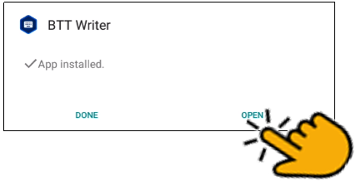
6. Tap **ALLOW** to enable BTT Writer to access photos, media, and files on your device.  
   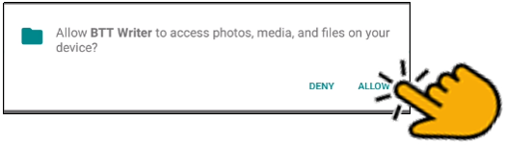  
     
   There may be an automatic update before the BTT Writer app opens.

## Choosing What to Translate

At some point, the translation team will have to figure out what they should translate first, or, if they have already done some translation, what they should translate next. There are several factors that need to be considered:

* What does the church want to be translated?
* How experienced is the translation team?
* How much Biblical content has been translated into this language?

The answers to these questions are important. But remember this:

**Translation is a skill that grows with experience.**

Because translation is a skill that grows, it is wise to start translating content that is less complicated so that the translators can learn the skill while translating something simple.

***Translation Difficulty***

Wycliffe Bible Translators have rated the difficulty of translating the different books of the Bible. In their rating system, the most complicated books to translate receive a level 5 difficulty. The easiest books to translate are a level 1.

In general, books that have more abstract, poetic, and theologically loaded terms and ideas are more difficult to translate. Books that are more narrative and concrete are generally easier to translate.

**Difficulty Level 5 (Most Difficult to Translate)**

* + Job, Psalms, Isaiah, Jeremiah, Ezekiel
* New Testament
  + Romans, Galatians, Ephesians, Philippians, Colossians, Hebrews

**Difficulty Level 4**

* Old Testament
  + Leviticus, Proverbs, Ecclesiastes, Song of Solomon, Lamentations, Daniel, Hosea, Joel, Amos, Obadiah, Micah, Nahum, Habakkuk, Zephaniah, Haggai, Zechariah, Malachi
* New Testament
  + John, 1-2 Corinthians, 1-2 Thessalonians, 1-2 Peter, 1 John, Jude

**Difficulty Level 3**

* Old Testament
  + Genesis, Exodus, Numbers, Deuteronomy
* New Testament
  + Matthew, Mark, Luke, Acts, 1-2 Timothy, Titus, Philemon, James, 2-3 John, Revelation

**Difficulty Level 2**

* Old Testament
  + Joshua, Judges, Ruth, 1-2 Samuel, 1-2 Kings, 1-2 Chronicles, Ezra, Nehemiah, Esther, Jonah
* New Testament
  + *none*

**Difficulty Level 1 (Easiest to Translate)**

* *none*

**Open Bible Stories**

Though Open Bible Stories was not assessed according to this rating system, it should fall under Difficulty Level 1. We recommend that you begin by translating Open Bible Stories. There are many good reasons to start by translating Open Bible Stories:

* Open Bible Stories was designed to be easily translated.
  + It is largely narrative.
  + Many difficult phrases and words have been simplified.
  + It has many pictures to help the translator understand the text.
* Open Bible Stories is much shorter than the Bible or even the New Testament, so it can be quickly completed and distributed to the Church.
* Since it is not Scripture, Open Bible Stories removes the fear that many translators have of translating the Word of God.
* Translating Open Bible Stories before translating the Bible gives the translators experience and training in translation, so that when they translate the.

Bible, they will do it well. By translating Open Bible Stories, the translation team will gain:

* Experience in creating a translation and checking team
* Experience in doing the translation and checking process
* Experience in using the translation tools
* Experience in resolving translation conflicts
* Experience in getting church and community participation
* Experience in publishing and distributing content
* Open Bible Stories is a great tool to teach the church, evangelize the lost, and train the translators in what the Bible is all about.

You can work your way through the Stories in whatever order that you want, but we have found that Story #31 (see <http://ufw.io/en-obs-31>) is a good first story to translate since it is short and easy to understand.

***Conclusion***

Ultimately, the church needs to decide what they want to translate, and in what order. But because translation is a skill that improves with use, and because the translation and checking teams can learn so much about translating the Bible by translating Open Bible Stories, and because of the immense value that the translated Open Bible Stories gives to the local church, we highly recommend starting your translation project with Open Bible Stories.

After translating Open Bible Stories, the church will need to decide if it would be more beneficial to start with how everything began (Genesis, Exodus) or with Jesus (New Testament gospels). In either case, we recommend starting Bible translation with some of the Difficulty Level 2 and 3 books (like Genesis, Ruth, and Mark). Finally, after the translation team has a lot of experience, then they can start translating Difficulty Level 4 and 5 books (like John, Hebrews, and Psalms). If the translation team follows this schedule, they will make better translations with far fewer mistakes.

## How do I use BTT Writer for the first time?

Complete these steps to use BTT Writer for the first time:

1. If BTT Writer is open, skip to step 3. If it is not open, tap the **BTT Writer icon**  on the tablet (this icon may not be on the main screen; you may need to scroll to a different screen to find it, or open your apps.)

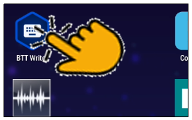

1. Create or login to your account. See Login Options for more information.
2. Read and agree with each of the statements in the Terms of Use by performing the following steps:
   1. Tap each statement.
   2. Scroll through the text to read the entire statement.
   3. Tap **Close** for each statement.
   4. When you have read all statements, tap **I Agree**.

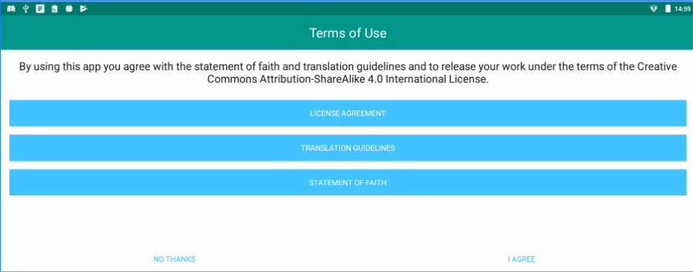

**Note:** At any time you can view the License Agreement, Statement of Faith, Translation Guidelines and the Software Licenses information from the Settings Menu. (See: Modifying Program Settings)

1. The program opens to the *Your Translation Projects* screen (which is the home screen).

### Login Options

The welcome screen displays a request to create or log in to a user account.  
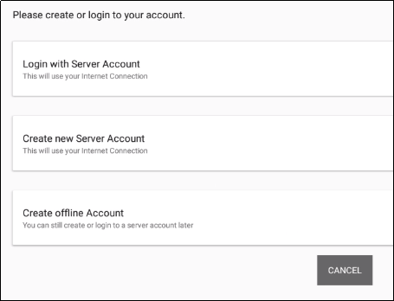

#### **Which Type of Account Do I Want to Use?**

**Server Account** – user has full use of the program and can upload to the server (requires Internet connection.)

Note: The server that you connect to is determined by the Content Server setting. You can connect to the Wycliffe Associates Content Server (WACS) or the Door43 Content Server (DCS). See Modifying Program Settings. You can change this setting before you log in or at any time while using the program.

**Offline Account** – user has full use of the program except for uploading to the server. You may want to start with an offline account and then switch to a server account later when you want to upload your work (the work is attached to the device, not to the account). If you want to use an offline account, skip to the Local Login or Offline Account section.

#### **Existing** Server Account

If you already have a server account, you can log in with it. If not, skip to the New Server Account section.

1. On the opening screen, tap **Login with Server Account**.   
     
   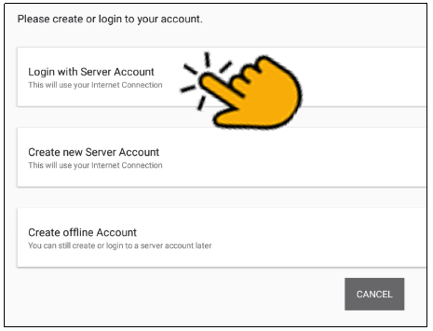
2. The login screen opens. Type in your server account information and tap **Continue**.  
   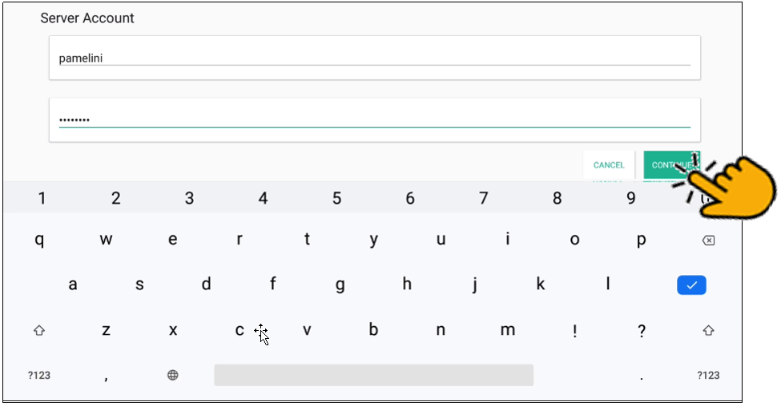
3. Skip to the How Do I Start a New Project? section.

#### New Server Account

If you do not have a server account, but you wish to be able to use an Internet connection to upload your work to the server, you can create a server account.

1. On the opening screen, tap **Create new Server Account** to create a new server user account. The Server Account Creation window opens. (This requires an Internet connection.)  
     
   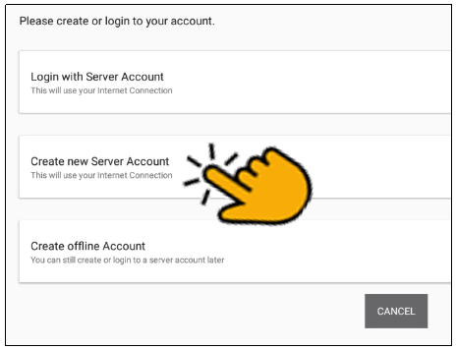
2. Tap the **Your Name or Pseudonym** field and type your user name or pseudonym into the field. This is the display name -- the name that will be listed as a contributor to any project files on this device.

**Note**: Because names are publicly available, you may prefer to use a pseudonym. A pseudonym is a name that cannot be traced back to you. Make up any pseudonym of your choice.

1. Tap the 'Email Address' line to enter your email address.
2. Enter your name or pseudonym in the **Login name** field. This is your server user name that you will use to log in to the server and to the BTT Writer app. If you used a pseudonym in step (2) above, enter the same pseudonym here.
3. Enter a password in both fields. (Tap **Show Passwords** at the bottom of the screen if you want to display the passwords.)
4. Confirm the information, and then tap **Continue** to begin registration.  
   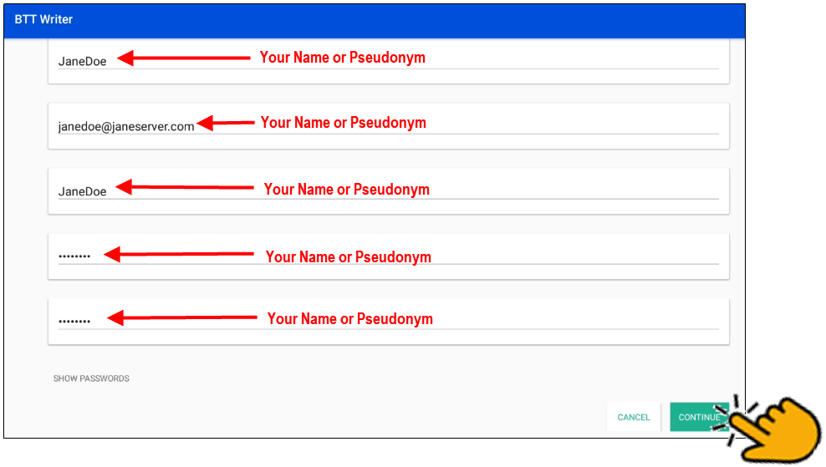
5. Tap **Continue** to acknowledge the privacy notice.  
   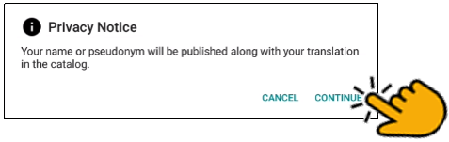
6. Skip to the How Do I Start a New Project? section.

#### Local Login or Offline Account

If you do not want to create a new server account at this time or are not able to connect to the Internet., you can create an offline account.

1. On the opening screen, tap **Create offline Account**. The login screen opens.  
     
   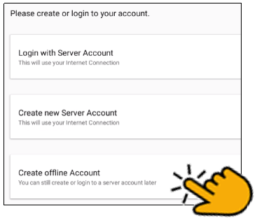
2. Tap the **Your Name or Pseudonym** field.   
   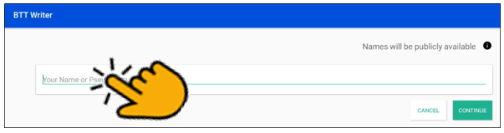
3. Type your user name or pseudonym into the field, and then tap **Continue**.   
     
     
     
     
     
   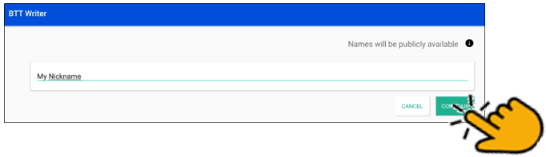

**NOTE:** You may use a pseudonym instead of your real name. A pseudonym is a name that cannot be traced back to you.

1. Tap **Continue** to acknowledge the privacy notice.  
   
2. Skip to the How Do I Start a New Project? section.

### **Agreeing to Terms of Use**

After you have logged in for the first time, BTT Writer displays the Terms of Use. Read and agree with each of the statements in the Terms of Use by performing the following steps:

1. Click each statement.  
   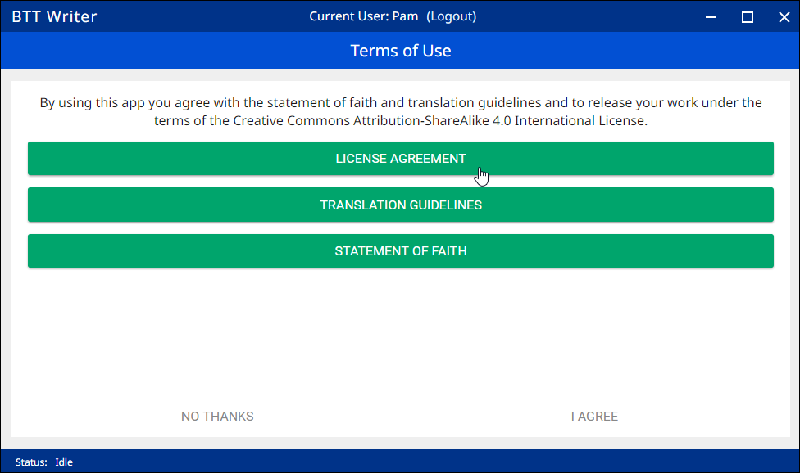
2. Scroll through the text to read the entire statement. Click **Close** for each statement.  
   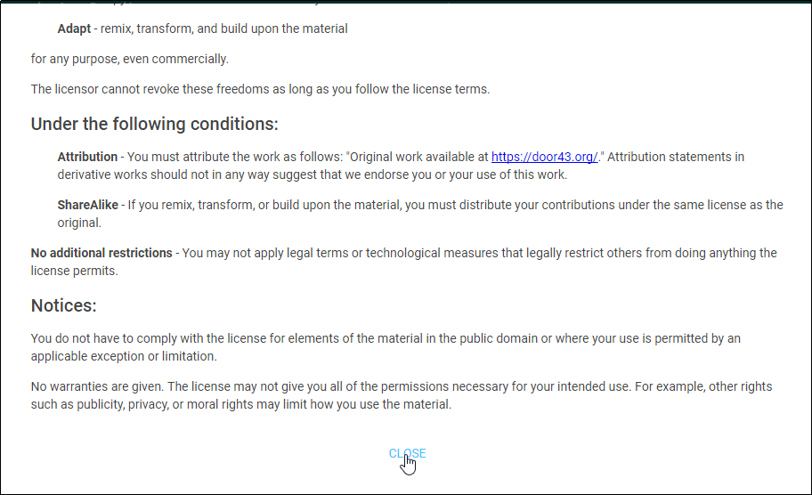
3. When you have read all statements, click **I Agree**.   
   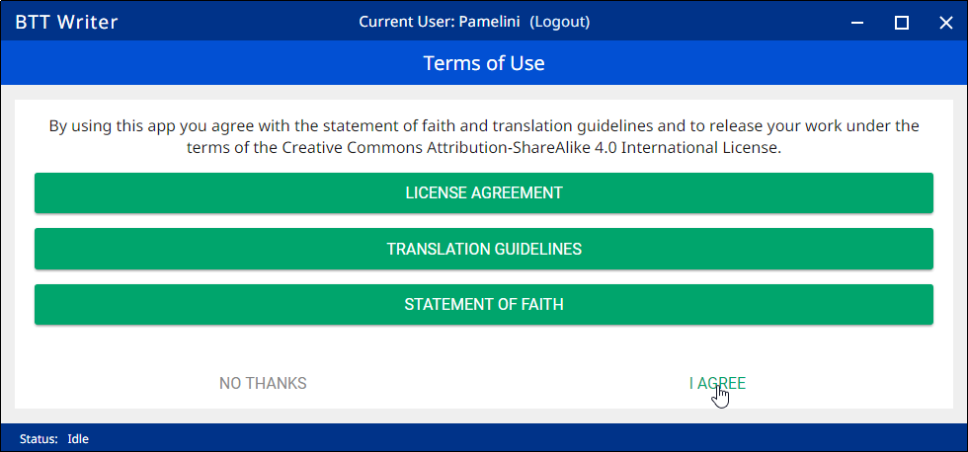

**Note:** At any time you can view the License Agreement, Statement of Faith, Translation Guidelines and the Software Licenses information from the Settings Menu. (See: Modifying Program Settings)

The program opens to the *Your Translation Projects* screen (which is the Home screen). The first time you use the program you have no existing projects, so the Home screen displays a welcome message.

### **Logging Out**

**You do not need to log out of the app before you close it. If you do not log out, when you reopen BTT Writer you will still be logged in.**

**However, you may want to log out to change the logged-in user. For example, you may do your work offline with an offline account, but when you want to upload your work you need to use a server account.**

**At any time you can perform the following steps to access the initial screen to change login or translator settings:**

* From the *Your Translation Projects* screen:
  + Tap the 3-dot icon  to invoke the options menu. This icon is at the lower left if your tablet is held horizontally, or at the lower right if the tablet is held vertically.
  + Tap **Log out.**

OR

* Tap **Logout** at the top right of the screen next to the user name.  
  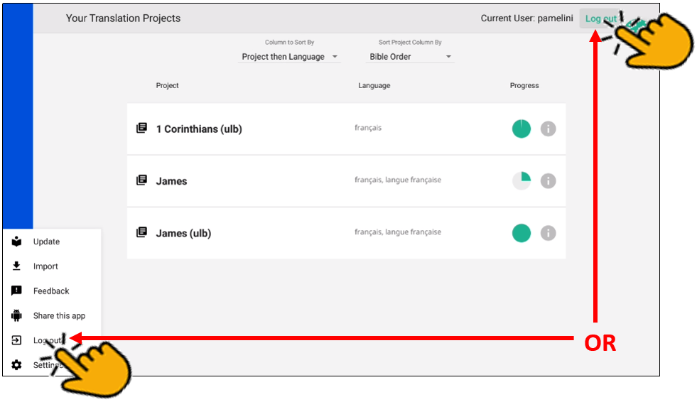

### How do I Start a New Project?

The first time you use the program you have no existing projects, so the home screen displays a welcome message. in the upper right ***or*** the **Start a New Translation** button at the bottom to start a new project.  
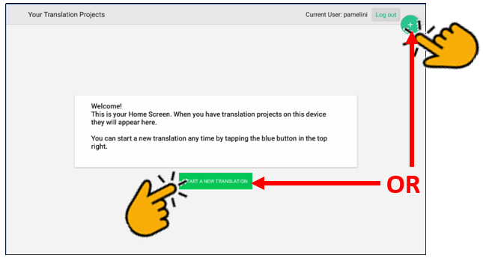

A translation project consists of:

* A target language - the language into which you will be translating
* A project category - what you will be translating, such as Open Bible Stories or a book of the Bible
* A source language and text - the language and text you will be translating, such as the English ULB (Unlocked Literal Bible)

So, to start a translation project, you must specify each of these elements.

#### *How do I select the target language?*

When you start a new project, you need to choose the target language (the mother tongue language *into* which you will be translating). The target language that you choose is incorporated into the name of the project.

1. Choose your target language (the one you will be translating *to*):
   1. Swipe up (place a finger on the white area and slide up) to find the target language    
        
      **OR**
   2. Tap the magnifying glass icon  located at the top right of the screen.
      * The search field opens and the keyboard appears.
      * Type the first few letters of your language to narrow the language list.
   3. Tap your language to select it.  
      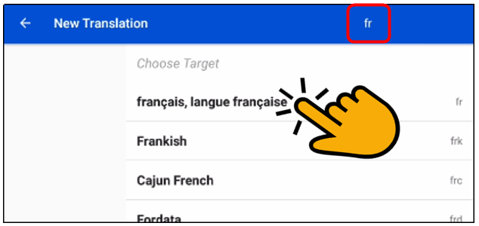

What if your target language is not listed? Then see What if I can’t find my language? for information on searching and requesting a new language.

##### What if I can’t find my language?

If you do not see your language in the list of target languages, first try alternate spellings, dialect names, and any variant names for your language. If you still can't find it, you can request that your language be added to the list of languages in the BTT Writer app.

The best way to submit a request is to send an email to <mailto:helpdesk@techadvancement.com>. Another method is to use the Feedback option from the options menu to submit a bug report. In either case, please provide as much information as you can about the language, such as the local name of the language, any other names it is known by, approximate number of speakers, where it is spoken, any similar languages, any published works in that language, etc.

Use Feedback in the 3-dot options menu to request a new language:

1. From any screen in BTT Writer, tap the 3-dot icon  on the left or bottom.
2. In the list of options, tap **Feedback**.
3. The **Feedback** screen opens. Type the name of the language you would like added to BTT Writer. Provide the location pf the speakers and other names the language is known by. If you used a language that is already in the APP, tell which language you used.
4. Tap **Confirm** to send your request.  
   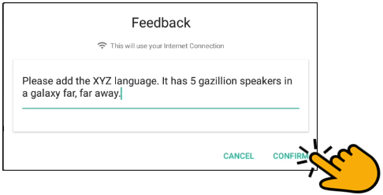

Note that even after requesting a new language, certain approvals are required before it will be added to BTT Writer. Until your language is added to the app, use *English Demo1* or *English Demo2*. You will need to use the Feedback option from the options menu to send a comment stating that you used another language for your own. Once your translation has been received, the technicians will put it in the correct language. Your translation will then show in your language.

##### Can I change the target language of an existing project?

If you make a mistake and designate the wrong target language, after you have finished defining the project, you can change the target language.

* On the Home page, tap the  icon next to the project whose target language you wish to change.
* On the information window, tap **Change** next to the target language.  
  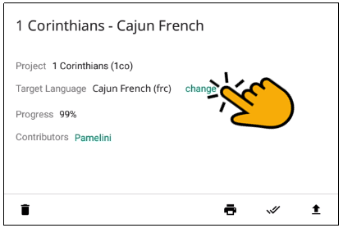
* The *Choose target language* window appears, enabling you to select a different target language. As soon as you select a language, the language shown for the project is changed.

#### How do I select what to work on?

We recommend that you begin by translating Open Bible Stories. You can work your way through the Stories however you want, but we have found that Story #31 (see <https://door43.org/en/obs/31>) is a good first story to translate since it is short and easy to understand. For more information read Choosing What to Translate.

To designate what to work on for this project, complete the following steps:

1. Choose a project from the *Bible: OT*, *Bible: NT*, or *Open Bible Stories* to start translating.  
   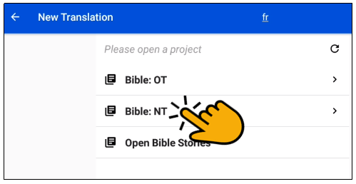
2. If you choose either the Old or New Testament, you next choose a book for the project.  
   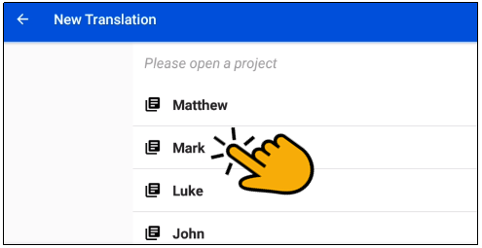
3. The new translation project opens showing the Chapter or Story view. If you choose an *Open Bible Stories* project, it opens to the first paragraph of The Creation

#### How do I select or change the source text language?

You can select and/or change your source text language whenever you use BTT Writer.When first creating a new project, you must select a source text language. This is the text you will be translating *from*.

In the translation project complete the following steps to select or change the source text:

* Tap the rectangular icon with the + and - sign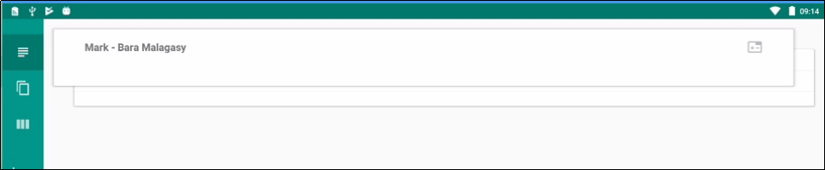 found at the top right of the source text window. If you are selecting the source text(s) for a new project, you can tap anywhere in the lower part of the window.  
  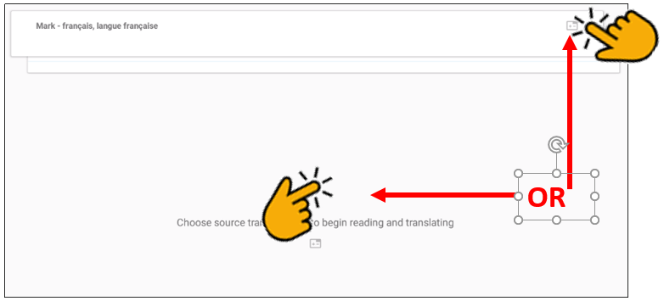
* Tap the empty square box(es) next to the desired source text(s). You can scroll down to see additional languages, or search by using the magnifying glass icon at the upper right of the *Choose source translations* box.  
  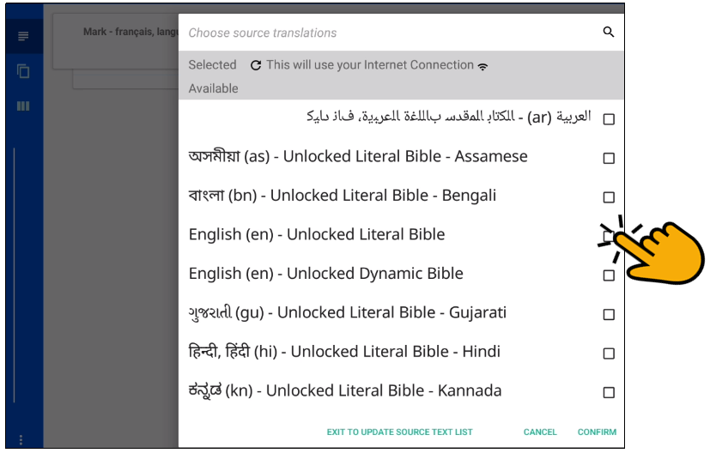  
  You can choose multiple source texts; those selected are moved to the top portion of the *Choose source translations* box under the *Selected* heading.
  + Choosing multiple source texts enables you to compare them as you are performing the translation work.
  + For example, when translating the you should always choose the Unlocked Literal Bible (ULB) as a source, but you may want to also choose the Unlocked Dynamic Bible (UDB) if it is available in your language because it may be easier to understand. Looking at the UDB may help you to translate or check a passage.

To save the selection(s), tap **Confirm** at the bottom right of the *Choose source translations* box, OR tap **Cancel** to close without saving the selected language.   
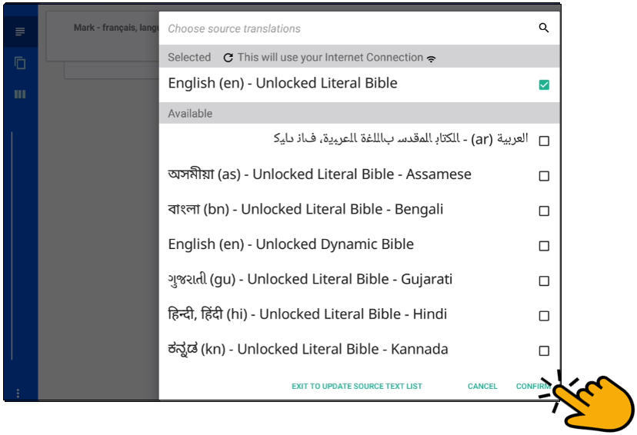

|  |
| --- |
| **Note**: You are not able to work in a project until you choose a source text language. |

## How do I navigate in BTT Writer?

### Layout

There are two screens in the BTT Writer app:

* The Home screen, or *Your Translation Projects* screen, shows any projects that have been created on the tablet. The Home screen also shows the user name and a Log out button.  
  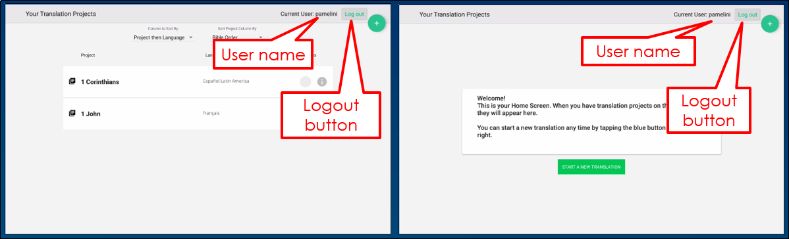   
    
  If there are no projects, the Home screen displays a welcome message.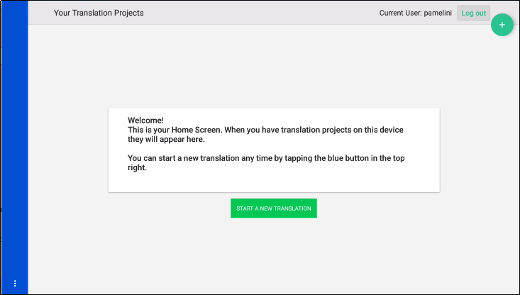
* The *Project* screen is where you perform the translation work on a single project. It shows the source text and the translated text and can also display translation resources.  
  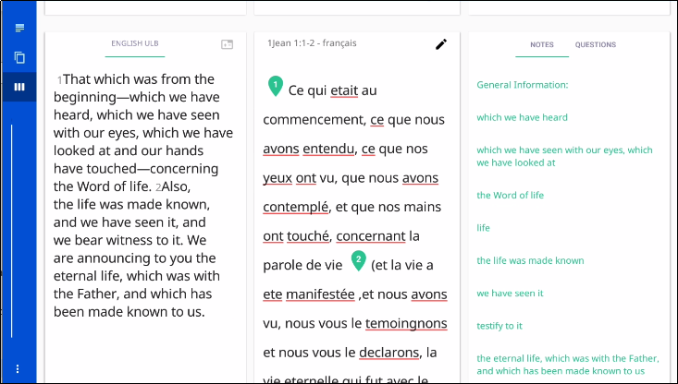

The *Project* screen can display three different views of these and contains navigation and menu icons to enable you to move around in the program.

The navigation and menu icons are on the left of the screen if you hold the tablet or phone in a horizontal position, and at the bottom of the screen if you hold the device in a vertical (tall) position.  **It is best to hold the tablet or phone in a horizontal position.**

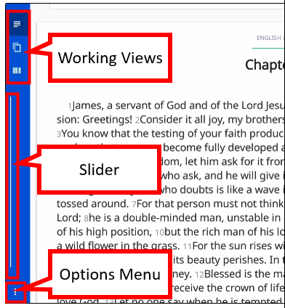

In the horizontal position:

* The top three icons are the working views.
* The slider in the middle moves through the text.
* The options menu is the three dots icon at the bottom.

### Working Views Icons

The **Chapter or Story** icon  is the top working views icon on the left (held horizontally) or bottom left (held vertically) and looks like 3½ horizontal lines.

* Swipe up to read the entire chapter or story in the source text language.
* Swipe to either side, or tap the page behind the text, for a blank page to enter the target language translation of the text. (See: Translate Text for more information.)  
  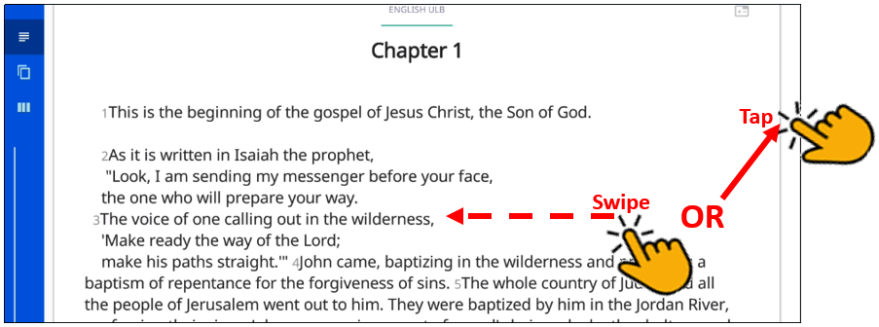

The **Chunk** icon  is the middle working views icon on the left (held horizontally) or bottom (held vertically) and looks like two pages, one behind the other. This shows the text divided into chunks, or small sections of the story or chapter.

Swipe down or up to move from chunk to chunk or use the Slider.

Swipe to the side, or tap the page behind the chunk, for a blank page to type in the target language translation of the text, or to see the translation if work has already been done on that chunk.  
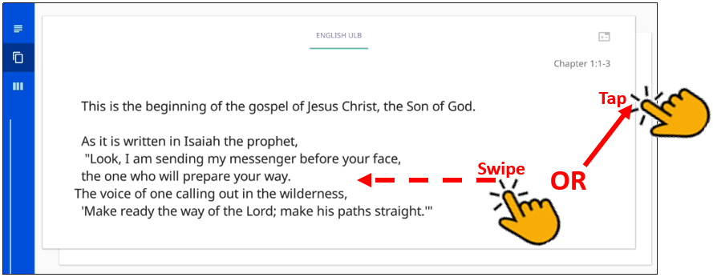

The **Check** icon  is the last working views icon on the left (held horizontally) or bottom (held vertically) and looks like three vertical lines. In this view the source text is on the left and the translation work is on the right.

Swipe up or down to move from chunk to chunk. Swipe from the right to the left side, or tap in the right margin, to show the resources for that chunk. (See: Using the Resources for more information.)   
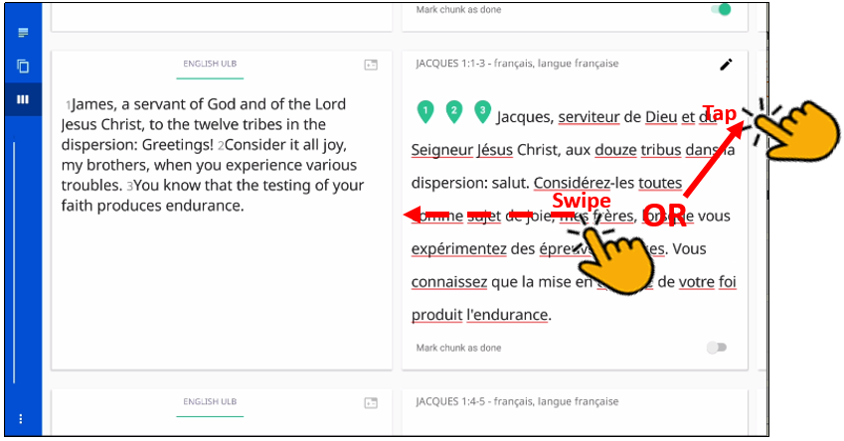  
  
The **Resources pane** is divided into three tabs. All of the **translationNotes**, **translationWords**, and **translationQuestions** are included in BTT Writer. See Find the Resources (translationHelps) in BTT Writer for more information. Tap either **Notes**, **Words**, or **Questions** to navigate among the tabs. If there are no existing resources for a particular chunk, the resources pane is blank. If there are no resources of one of the types (such as Words), then that tab does not exist on the resources pane (you would see only the Notes and Questions tabs).  
 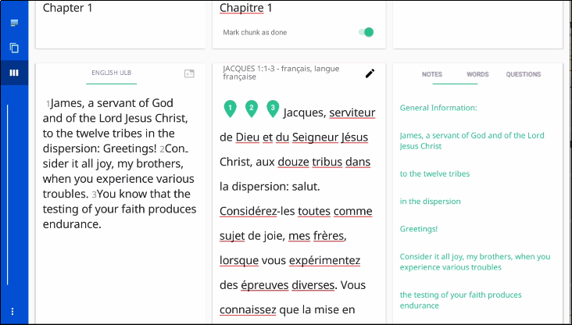

### Slider

The **Slider** icon is a quick way to move through a story or book of the Bible. Tap-and-hold the slider and drag it towards the bottom (right) or the top (left). Numbers may appear on the line that represent the chapter of the book at that location of the slider.  
 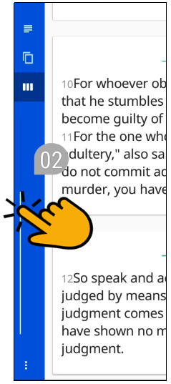

### Options Menu

Tap the **three dots icon**  at the bottom left (or right) of the screen to open the options menu. The Project screen and the *Your Translation Projects* screen (home screen) have two different menus.

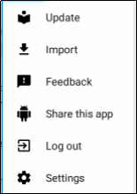On the *Your Translation Projects* screen the options menu includes the following options:

* Update – update source or target language file or the BTT Writer app
* Import – import project or source text
* Feedback (See: <http://help.door43.org/en/knowledgebase/9-translationstudio/docs/29-report-problems-and-making-suggestions>)
* Share this app – share with another device or email
* Log Out – log out so you can log in as a different user
* Settings (See Modifying Program Settings)

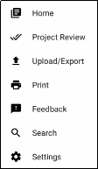  
On the Project screen the options menu includes:

* Home – return to the *Your Translation Projects* screen (home screen)
* Project Review – prepare for publishing
* Upload/Export – upload to a server or export to a file
* Print – print to PDF file
* Feedback – report a bug
* Search – search source text
* Settings (See Modifying Program Settings)

## How do I translate in BTT Writer?

A basic translation process for any unfoldingWord project is explained here.

As you translate, be sure that you:

* Pray that God would help you make an easily-understandable, Scripturally-accurate translation
* Translate everything that is in the source text language.
* Do not add anything that that is not necessary for comprehension.
* Always do your translation according to the Translation Guidelines (see <https://read.bibletranslationtools.org/u/WycliffeAssociates/en_tm/dc23f839f6/#translation-guidelines>).
* Always do your translation according to the Statement of Faith (see <https://bibleineverylanguage.org/statement-of-faith/>).
* Use the Translation Notes, Words, and Questions to help you make a better translation (these resources are available within BTT Writer – see Using the Resources).

BTT Writer is designed to work with the MAST process and is organized to work with blind drafting. You may want to read [https://bibleineverylanguage.org/processes/mast/](https://bibleineverylanguage.org/processes/mast/%20) to understand the steps of blind drafting translation.

### Translate Text

To write the translation in your language:

1. Open the project that is being translated.
2. The screen is arranged to appear like two sheets of paper, one behind the other, with the **Chapter or Story** view initially on top. In this view, read the source text.
   1. The app is organized to work with blind drafting.
3. You may want to read  <https://bibleineverylanguage.org/processes/mast/> to understand the steps of blind drafting translation.
4. When you are ready to begin translating, tap the “piece of paper” that is behind the one you have been reading.  
   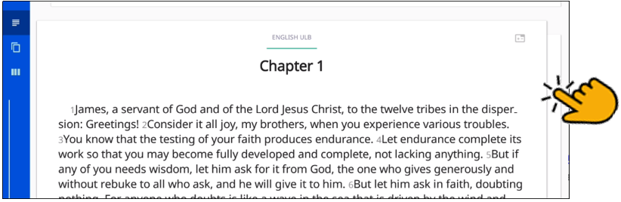
5. Tap the **Begin Translating** icon.   
   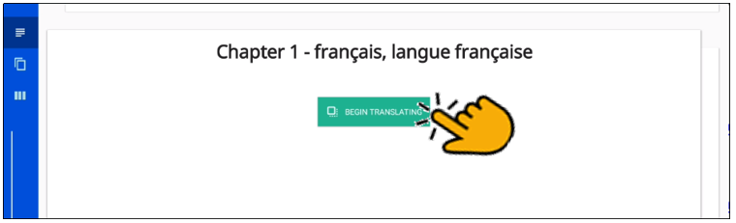
6. The **Chunk** view appears and displays the text divided into chunks, which are sections that you should be able to retell without looking. Read a chunk over until you can remember what it says.
7. Tap the blank paper behind the one containing the text.   
   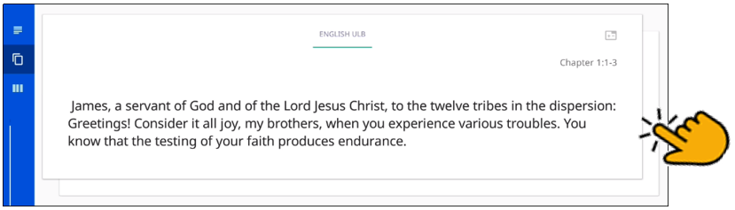
8. Tap anywhere on the blank sheet of paper to open a keyboard to begin working.   
   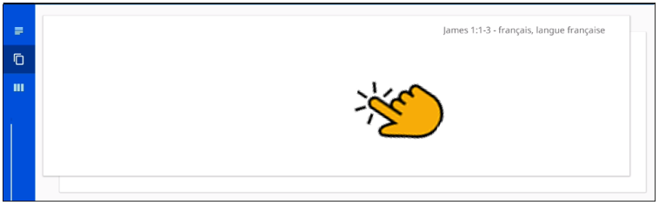
9. Type in the translation for that chunk on the page. This should not be a word-for-word translation, but it should be expressed in a way that would sound natural to a native speaker of the language.  
   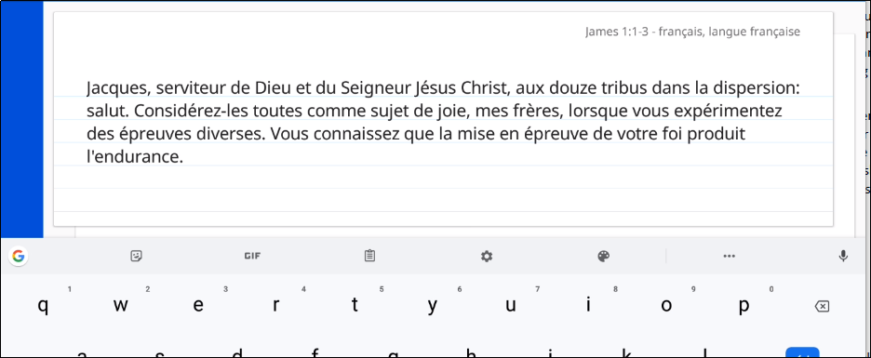  
   1. Start translating with a blind draft. Set aside the source text and draft the chunk as well as you can without looking back at the text.
   2. Write everything that you remember about that chunk.
   3. Do not look back at the source text for this chunk until you begin the editing steps.
10. When you are finished working, swipe up to work on the next chunk.  
    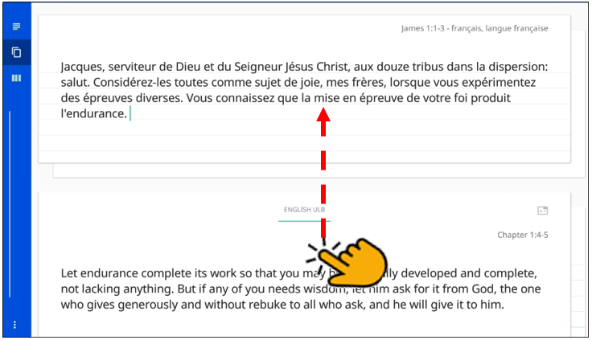
11. Continue doing this with each chunk of the chapter before moving to the checking steps.

### Check and Edit Translated Text

When you use BTT Writer, you can use the **Check**view to edit existing work that you or another translator created. Your work is saved automatically every five minutes.

To enter the Check view, tap the **Check View icon**  at the left or bottom of the page.

In the Check view the source text is on the left and the translation work is on the right. You can compare the two and then edit the translation to include all details in the source text.

In the Check view you can access the Translation Notes, Words and Questions that have been included in the program. See Using the Resources  for more information.

If you need to make changes in the translated text, perform the following steps:

1. Tap the **pencil icon**  at the top right of the translated chunk.   
   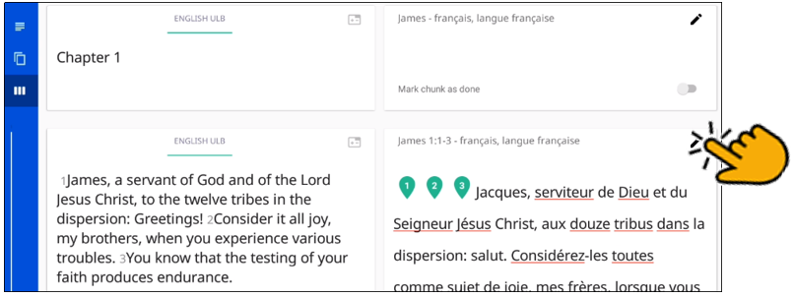
2. The keyboard appears. Edit the text to include all details and correct any grammatical or spelling errors.  
   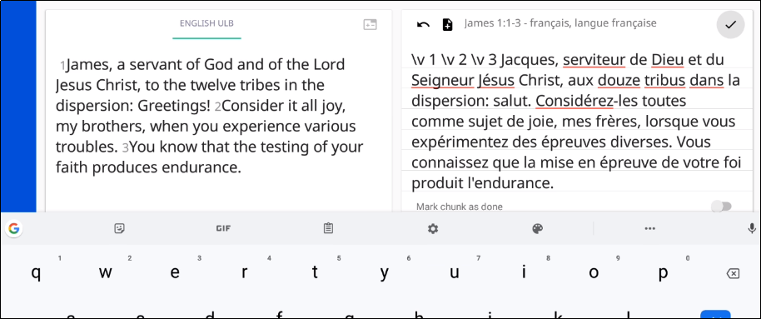
3. Tap the check mark icon  when done editing. The keyboard disappears.  
   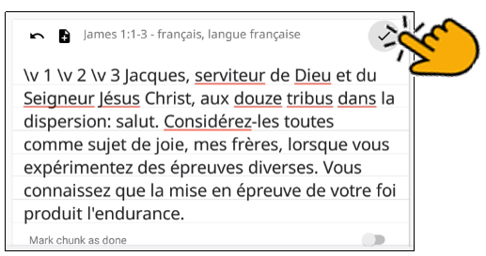
4. Place the verse markers (skip this step if you are translating Open Bible Stories, which are not divided into verses).
   1. There is a verse marker for each verse in the chunk.
   2. Tap and hold each verse marker and drag it to the beginning of each verse, dropping it above and slightly to the left of the location where it should go.  
      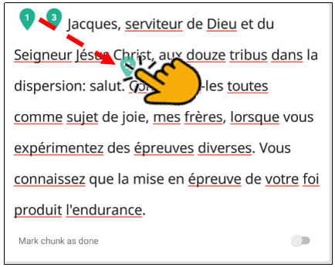 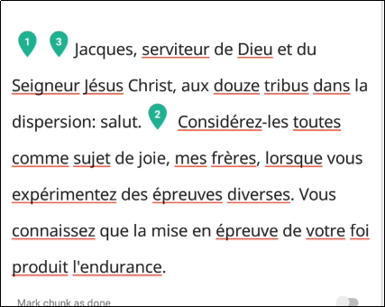
   3. Continue until all verses are marked with a verse number.
5. When you are finished working, use the toggle  at the bottom of the chunk to mark the translation of that chunk done. Slide the toggle to the right, or just tap it, to indicate that the chunk is finished.  
   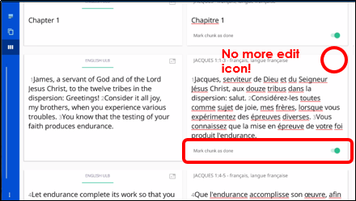  
   1. A message appears for you to confirm that the chunk is done. Tap **Confirm** to indicate that the work is done or **Cancel** to continue editing.  
      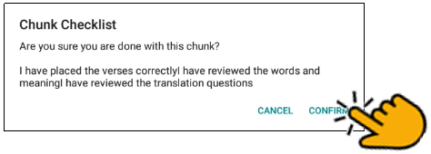

At any time you can slide the toggle  back to the left, or just tap it, to edit the chunk again. Use the above steps to edit.

#### Recovering Deleted Translation Text

If you accidentally delete a large amount of work, contact [helpdesk@techadvancement.com](mailto:helpdesk@techadvancement.com).

### Using the Resources

Bible resources – Translation Notes, Translation Words, and Translation Questions -- are included in the BTT Writer mobile app.

Tap the **Check** icon  that looks like three vertical lines.

Swipe from the right to the left side, or tap in the right margin, to show the resources for a chunk.   
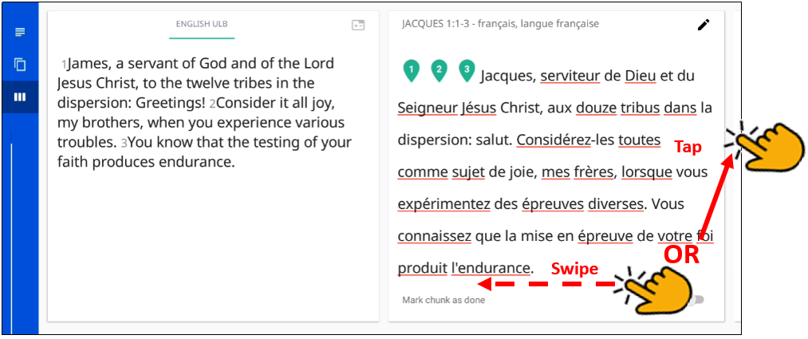

The Resources pane is divided into three tabs: Notes, Words, and Questions.   
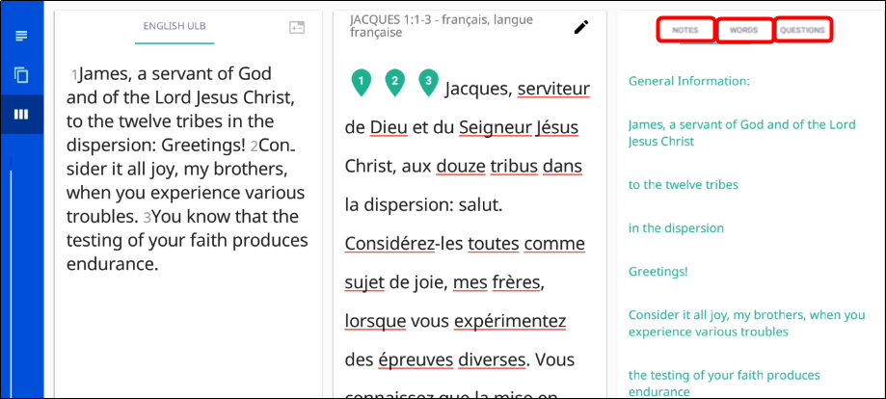

If there are no existing resources for a particular chunk, the resources pane is blank. If there are no resources of one of the types, then that tab does not exist on the resources pane. For example, if there are no Words for a chunk, then you would see only the Notes and Questions tabs on the Resources pane for that chunk.

* Tap the **Notes** tab for the Translation Notes or the **Words** tab for the Translation Words.

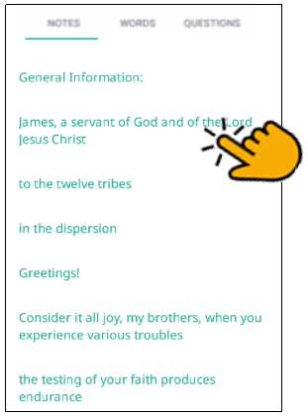

* The words or phrases are listed as they appear in the story or in the ULB.
* Tap the word or phrase for help in understanding how to translate into the target language. See <https://btt-writer.readthedocs.io/en/latest/Helps.html> for more information.   
  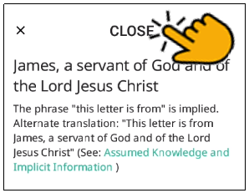
* Tap CLOSE to dismiss that word or phrase.
* Tap the **Questions** tab for the translationQuestions.   
  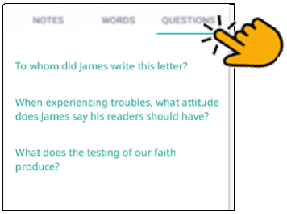  
  The questions are about information as it appears in the story on in the ULB. Read the question and answer it according to the translated text. Tap the question for the expected answer. If the given answer and the expected answer are not the same, then the translation might not be clear and accurate.

When you are done with the resources, swipe from left to right to make the pane disappear.

### How Do I Translate Footnotes?

A footnote is additional information about a certain part of the text. The footnote usually appears at the bottom of a book’s page.

In BTT Writer, a footnote is shown as a black page icon that you tap to display the footnote.

Footnotes can provide further explanation when:

* There are names or other words that differ between various Bible versions.
* Some versions of the Bible have words or verses that are not in the ULB.

To translate a footnote:

1. Tap the footnote in the source text to open it.   
   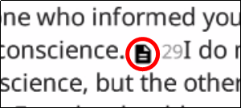 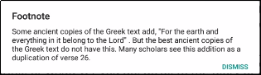
2. It’s not possible to copy/paste the footnote text.
3. You may need to write down the translation because you can’t have the original footnote open and type into the footnote translation at the same time.
4. Open the translated chunk for editing.  
    
5. Tap at the place in the translated text where you want to add the footnote.  
   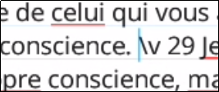
6. Tap the Add Footnote icon.  
   
7. Translate the footnote into the “Add Footnote” pop-up and tap OK.  
   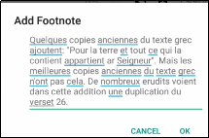
8. The footnote icon now appears inline. Tap the check mark to save the changes.  
   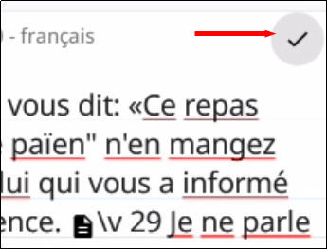

To edit or delete a translated footnote:

1. Ensure the chunk is **not** marked done and that you are **not** in Edit mode.
2. Tap the footnote.  
   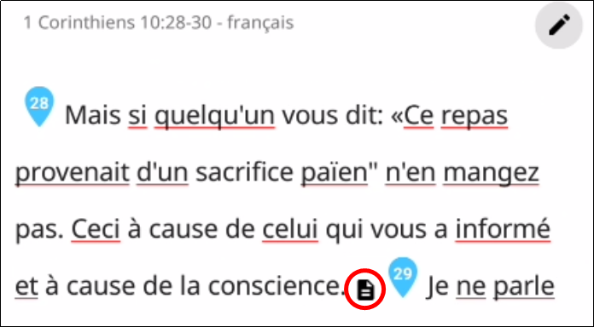
3. Tap **DELETE** to delete it or **EDIT** to edit it.  
   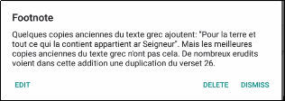
4. When finished, mark chunk as done.  
   

## Uploading/Exporting Your Work

When you work in BTT Writer, your text is saved every five minutes to your device. Your work is not saved to the server until you upload it.

While you are in a project in BTT Writer, tap the 3-dot icon  to access the options menu. Select **Upload/Export** (the upward arrow icon ).   
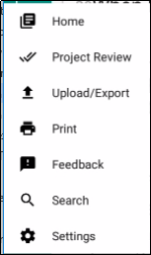

There are six Upload/Export options.  
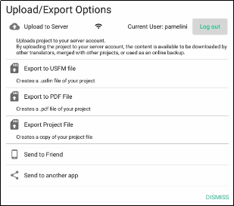

* Tap **Upload to the Server** to copy your work to the server, making it available to other translators and creating an online backup. You can upload to the server only if you have an internet connection and are logged in to a server account. A pop-up message appears after a successful upload. This pop-up message includes the repository that the translation is in on the server. Tap the link to view the repository. The translation has been uploaded to the server. There is a documentation process that takes place for public publishing. See Publishing Contentfor more information.

**Note**: The server to which you upload is determined by the Content Server setting (see Modifying Program Settings).

* Tap **Export to USFM or SD Card** to create a USFM (paratext) file. You can specify where to store the USFM file. Tap **Confirm** to start the export. 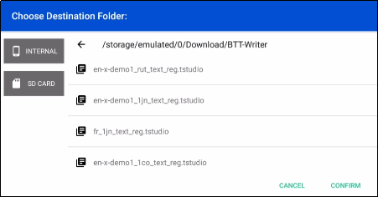   
    
    
  You can then edit the file name or leave it as is. Tap **CONTINUE** to save the file or **DISMISS** to cancel.  
  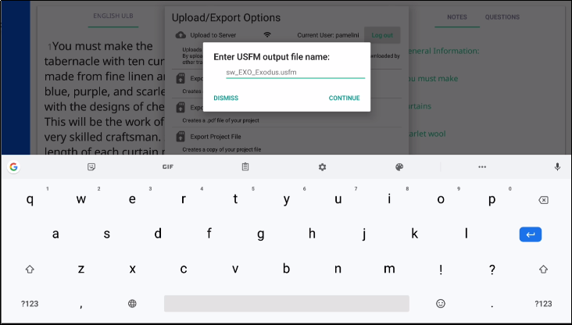  
    
  A pop-up message appears after a successful download to show the location of your file.   
  Tap **Dismiss** to dismiss the message once you make note of the file location.  
  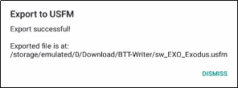
* Tap **Export to PDF** to create a PDF file of your work. You have the option to include incomplete chunks or not. When you have decided, tap **Print**.   
  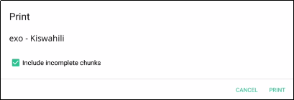  
    
  Choose your destination folder and tap **Confirm**.   
  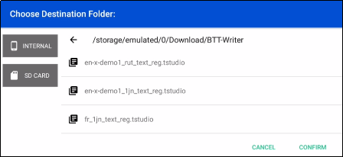   
    
  You can edit the file name or leave it as is, and then tap **OK**, or tap **Cancel** to cancel the export.  
  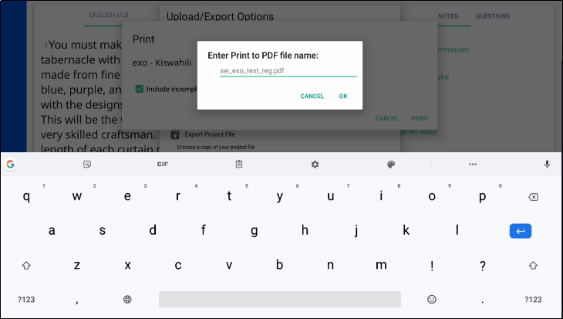  
    
  Choose where to share the PDF. A processing window appears (and may quickly disappear). Tap **DISMISS** to go back to the Upload/Export options.  
  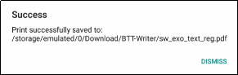
* Tap **Export Project File** to create a copy of the entire project file with a tstudio extension. The steps are the same as exporting to a PDF above.
* Tap **Send to Friend** to export the file to another device.
  + You are asked to specify a name for your device. Enter a name and then tap **Confirm**.  
    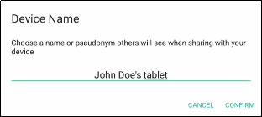
  + A window then displays all available devices. Tap the one where you wish to export the file.   
    If no devices are available, tap **Cancel**.  
    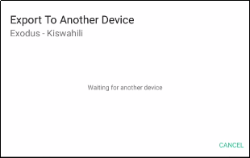
  + Close the window when told that the export process is complete.
* Tap **Send to another app** to send the file to other apps on your device, such as email. The icons that are shown are dependent upon the apps that are installed on your device. Tap the desired app:
  + Tap **Save to Drive**  to send your work to a Google Drive that has been created before. This requires an Internet connection.
  + Tap **Nearby Share**  or **Android Beam**  to send your work to a nearby device that has BTT Writer installed on it. The app will attempt to locate the device.
  + Tap **Bluetooth**  to send your work to a nearby device that is paired to yours through Bluetooth. If the app continues searching for more than a minute, exit the screen and verify that the devices are paired through Bluetooth.
  + Tap **Gmail**  to send your work to an email app. This requires an Internet connection. The app opens and enables you to send the project file as an attachment.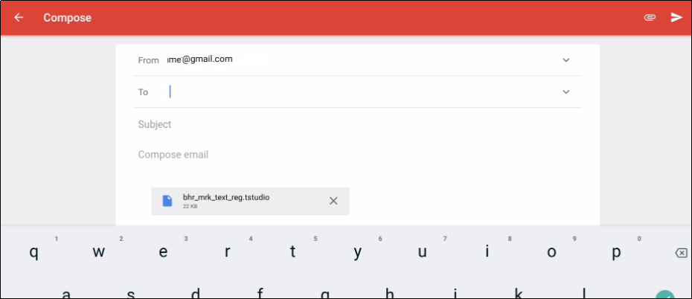

## Importing a Project

The BTT Writer program enables you to import a project from various sources. To import a project:

1. Navigate to the Home page.
2. Tap the 3-dot icon at the bottom left of the window.
3. Tap **Import** on the menu.

There are five options to choose from when importing to BTT Writer for Android.  
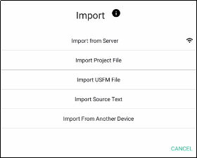

* **Import from Server:** This requires an Internet connection.

If you are logged into BTT Writer with a server account (either WA’s or Door43’s content server), choosing this option opens a window where you can search for server online projects. You will be able to import only text projects; Gateway Language projects (Words, Notes, or Questions) are not supported in the Android version of BTT Writer.

You can search for your own or another user’s project:

1. Tap in the *login name* field.
2. Type in the server user name of the user whose project you want to import.
3. Tap **Search**.

Another possibility is to search for a project by the book name or language:

1. Remove the user name from the *login name* search field.
2. Type in either the book abbreviation or the language code in the right field, or a combination of both (for example, fr_eph for French Ephesians).
3. Optional: type in a user’s account in the User Name field to also filter by the User.
4. Tap **Search**.

Once you have located the project you wish to import:

1. Tap the desired file to import it or tap **DISMISS** to close the option and return to the Import Options menu.  
   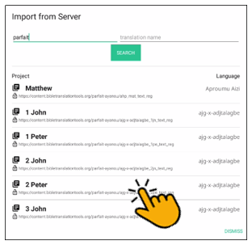
2. If you import the file, you receive a success message. Tap **CLOSE** to close the window.  
   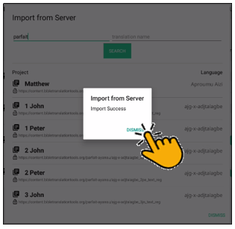

* **Import Project File**: This imports into the program a BTT Writer project from a file on the computer. These are files that have an extension of tstudio. Follow this process to import a tstudio file:

1. Tap **Import Project File** to import a project from the tablet’s storage.
2. The program opens the file explorer to the directory of the BTT Writer backups. Either choose one of the backup projects or navigate to the desired file.   
   **Hint**: you will be able to view only the files that have an extension of tstudio.
3. Tap to select the desired tstudio file, and then Tap **CONFIRM**.  
   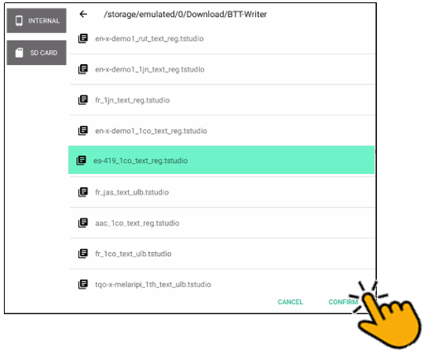
4. The import begins; when the import is completed a window displays a success message. Tap **DISMISS** to close the window.  
   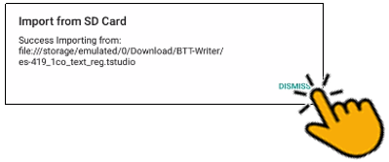

* **Import USFM File**: This imports a file that is formatted as a USFM document. Unified Standard Format Marker (USFM) is the international standard of Biblical text. Follow this process to import a usfm file:

1. Tap **Import USFM File** to import a file from the hard drive of the computer.
2. The program opens the file explorer to the BTT Writer backups folder. Navigate to find the desired file.
3. Tap the desired file, and then tap **CONFIRM**.  
   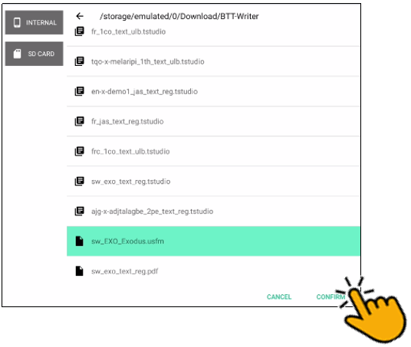
4. Tap to select the target language on the *Choose a Target Language* screen. You can search for a language by tapping the magnifying glass and then typing the first few letters of the language in the search field.  
   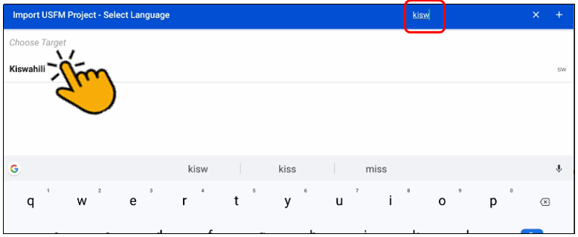
5. The remaining screens depend on what information is contained in the USFM file.

* You may be asked to choose a category. Tap the desired category to select it.
* You may be asked to choose a book name. Tap the desired book name to select it.
* You may be asked to choose the project type. Tap the desired type to select it.

1. A USFM Processing Summary is displayed. If no errors were found, tap **CONTINUE**.
2. The import begins, and when the import is completed a window displays a success message. Tap **CONTINUE** to close the window.

* **Import Source Text**: If you have a file containing source text that you want to use for a project, you can select this option to do so. Refer to the information on <http://resource-container.readthedocs.io/en/latest/index.html> to create your own source text file that can be imported into the BTT Writer program.

Making the choice to import source text opens the File Explorer. Navigate to the desired source text file, tap the file name, and tap **Open** to import it.

* **Import from Another Device**: This enables you to import a project from another device.

If you have not already named your device, you are first prompted to do so. Enter a name for your device and tap **CONFIRM**.  
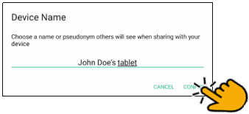

On the *Import From Another Device* pop-up, select the device where the project to be imported resides, or tap **CANCEL** if no device is found.   
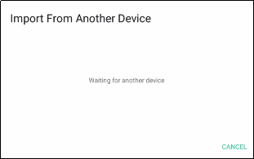

### Importing Duplicate Projects

If you are importing a project that is the same as a project already in the local program, you will receive a warning message that states *Project Already Exists*, with a summary of the chunks. 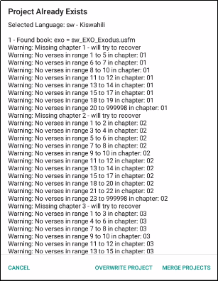

The possible actions for dealing with importing duplicate projects are:

* Cancel: Tapping **CANCEL** closes the message and the project does not get imported.
* Overwrite Project
  + We recommend that you do not choose this option if you have previously uploaded the project to the server.
  + If you run into difficulty you can always contact [helpdesk@techadvancement.com](mailto:helpdesk%40techadvancement.com) for help or submit a ticket using the following link: <https://www.techadvancement.com/submit-ticket/>.

**Warning:** Choosing to overwrite the project removes all information on the computer related to the previous local project and substitutes it with the information from the imported project.

* Merge Projects
  + The importing process continues.
  + When the message that the import is complete shows, tap **CLOSE**.
  + Open the project.
  + If the imported translation has recent changes, they now show in the text.

### Resolving Merge Conflicts

When you merge an imported project with one that already exists on your device, there may be differences between the information in the existing project and the information that is in the imported project. This is known as a conflict. When this happens, you see this message:

Merge Complete

The projects have been merged. There are (?) chunks that contain new conflicts that need your attention.  
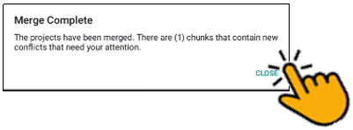

Resolve the differences by following these steps:

* Tap **CLOSE** to close the message window.
* The project opens.
* Observe that there is now a triangle icon  in the left column. Tap the triangle icon to view only the chunks with a conflict.
  + The text that was in the translation before the import is in the upper box.
  + The text that is new is in the lower box. In this example, the lower box is blank because there was no translation of that chunk in the imported file.  
    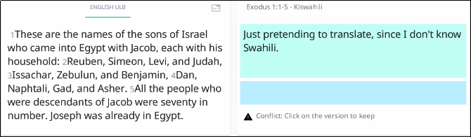
  + Tap the box containing the text that has the preferred translation.
  + Tap **CONFIRM** to use the selected text or tap **CANCEL** to deselect the text.  
    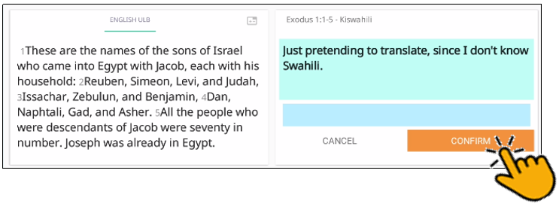
  + Once you confirm your preferred text, the text that you did not select disappears, and once all conflicts are resolved, the triangle icon disappears.  
    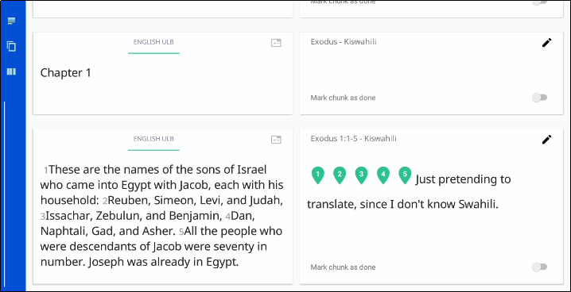

Repeat all the above steps until all the conflicts have been resolved by choosing the desired translations.

If you run into difficulty you can contact [helpdesk@techadvancement.com](mailto:helpdesk%40techadvancement.com) for help or submit a ticket using the following link: <https://www.techadvancement.com/submit-ticket/>.

NOTE: Resolve all conflicts before doing another export or import of the project

## Publishing Content

Publishing your project is a way to make your work available to others. There are two types of publishing:

* Self-publishing
* Source text publishing (only for Gateway Languages)

Self-Publishing

When you upload your work to the server it is automatically available online under your user account. This is referred to as self-publishing. You can upload to the server as often as you wish to create a backup of your work. (See Uploading/Exporting Your Work.)

You can access a web version of your project at

* For DCS: **http://door43.org**/u/*user_name*/*project_name*
* For WACS: **https://wacs.bibletranslationtools.org**/*user_name*/*project_name*

(where *user_name* is your user name and *project_name* is your translation project, comprising the target language code and the book code). The BTT Writer app gives you the correct link when you upload. You can also browse all works on

* For DCS: <https://git.door43.org/explore/repos>
* For WACS: <https://wacs.bibletranslationtools.org/explore/repos>

From your server project page you can:

* See the web version of your project with default formatting
* Download documents of your project (like a PDF)
* Get the links to the source files (USFM or Markdown) for your project
* Interact with others about your project

### Source Text Publishing

Source text publishing is required for all Gateway Languages so that they can be used as source texts by Other Languages. Note that **this process applies only to Gateway Languages**. There are several steps to the process of publishing your work.

#### Prerequisites

Before a Gateway Language translation can become a source text, the following prerequisites must all be met:

* Whole Resource - The whole resource must be translated and checked to the required level. Parts of resources (e.g. half of the Open Bible Stories, only a few chapters of a book of the Bible) cannot be published.
* Checking - A translation must have reached the appropriate checking level. For Bible translations, this is checking level 3: <https://bibleineverylanguage.org/faq/>.
* On the server - The server must have the version that will be published. If the work was done on multiple devices, then it may need to be merged together. Get the help of a Content Tech to make merging easier (email either [help@door43.org](mailto:help@door43.org)for DCS or [helpdesk@techadvancement.com](mailto:helpdesk@techadvancement.com) for WACS).
* Agreements - Everyone involved in the translation and checking must have agreed to the Statement of Faith, the Translation Guidelines, and the Open License. This can be done either by creating server accounts or by physically signing the documents and digitizing them (scanning or photos). See [http://ufw.io/forms](http://ufw.io/forms%20) for downloadable agreement forms.

You can use BTT Writer to ensure that the project is complete and that all contributors are listed. You can perform project review by completing the following steps to publish your work:

1. In BTT Writer, load your project.
2. Tap the **3-dot icon**  to access the options menu.
3. Tap **Project Review** (the double check marks icon).  
   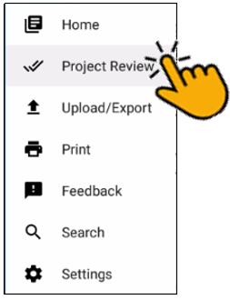
   * Tap the **Project** tab -- Review sections of the book for final review.   
     1. We suggest that you review any chunk that has a review button. These are chunks that are not marked done.
     2. Tap the **REVIEW** button.  
        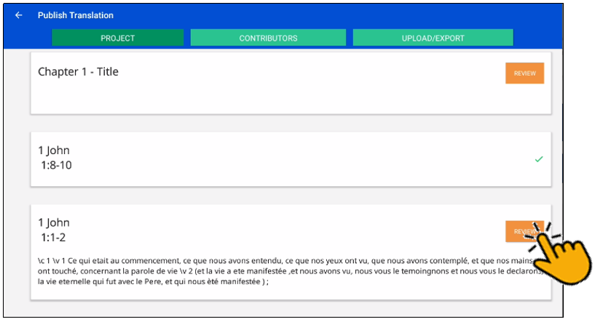
     3. Finish translating or set the verse markers and then slide the 'done' toggle. Then return to Project Review.
   * Tap the **Contributors** tab -- This is where you enter who translated the work. Remember that the names will be publicly available.
     1. Tap **Add Contributor**.  
        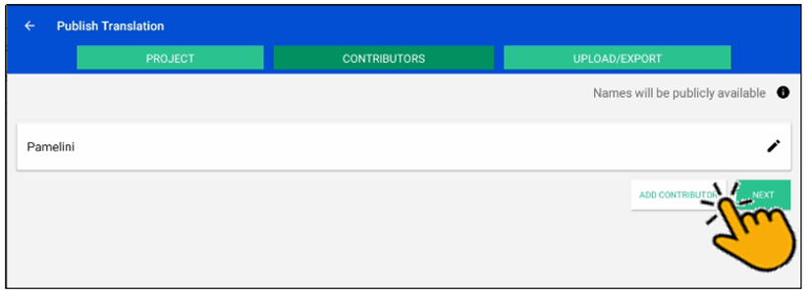
     2. In the Add Contributor pop-up window:
   * Tap the **Name or Pseudonym** line and enter the contributor’s name or pseudonym.
   * Tap the check box to indicate that this person has agreed to the terms of use.
   * Tap **Save** to add the translator.  
     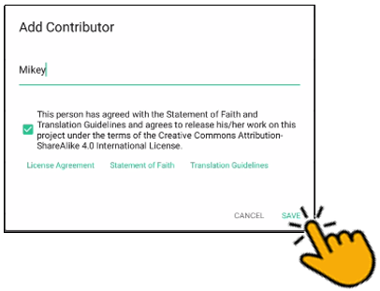
     1. Repeat steps 1 and 2 above for each contributor you want to add.
     2. When you have finished adding contributors, tap **Next** to continue, or tap the **Upload/Export** tab.  
        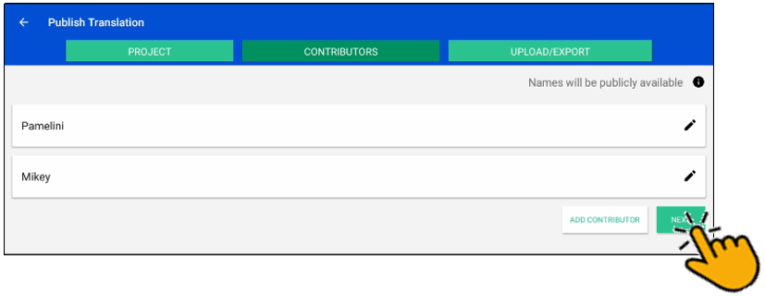
   * When you either tap Next in the step above, or tap the Upload/Export tab, you are presented with Upload/Export Options.
     1. Select **Upload to Server** (requires an Internet connection).
     2. A pop-up message appears after a successful upload. This pop-up message includes the repository that the translation is in on the server.
     3. Tap the link to view the repository.

#### Source Text Request Form

Once you have the prerequisites, you may fill out the source text request form at <http://ufw.io/pub/>. A few notes about the form:

* You must have a server account to create a request.
* You must include the names or pseudonyms of everyone involved. You must also include their server usernames if you are not attaching signed license agreements for them.
* Note that the information you enter will be public and will become a part of the front matter of the source text.

After you submit the form, you will be contacted if anything is missing. Once the request has been approved, it will go into the publishing queue where a developer will work to make the translation a source text. You may also be contacted by the developer if there are any issues encountered during the publishing process. You will be notified when the process is complete and you may review a PDF of the work.

#### Questions Regarding the Request to Publish Form and Process

##### What happens after text is approved?

When the Request to Publish is approved, the text is made available on <https://bibleineverylanguage.org/translations/> for online viewing, downloading, or printing.

##### Can text be changed after level 3 checking?

Approved text can always be modified in BTT Writer even after all checking levels are completed, HOWEVER if you or another user were to submit a Request to Publish for text that has already completed Level 3 checking, there would be questions regarding the reason for overwriting the previously published and checked materials. The approver will look to see who contributed to the change and may contact the requestor and others involved with the translation of the text in question to ensure the changes are valid.

##### Must all contributors be named?

Due to copyright laws (and these exist no matter what country you are in and no matter what people tell you about laws in that country), you must list every contributor as they prefer to be mentioned.  Normally this is the person's name or pseudonym.

## Modifying Program Settings

To open the settings window, tap the 3-dot icon  at the bottom left (or right) of the screen and tap **Settings** on the menu. You can access the settings window from either the Home page or the Projects page.  
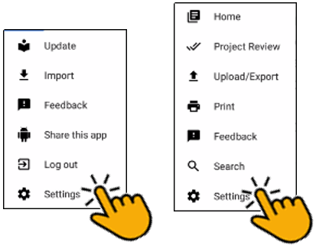

Tap the **Back Arrow** at the top left of the screen to exit the settings window.  
  
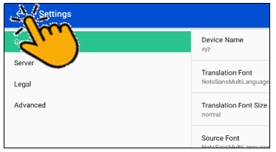

The Settings window allows for personalization of the program. It also displays useful information. Settings are divided into four categories:

1. General
2. Server
3. Legal
4. Advanced

### General Settings

****Tap **General** to view or change general settings.  
  
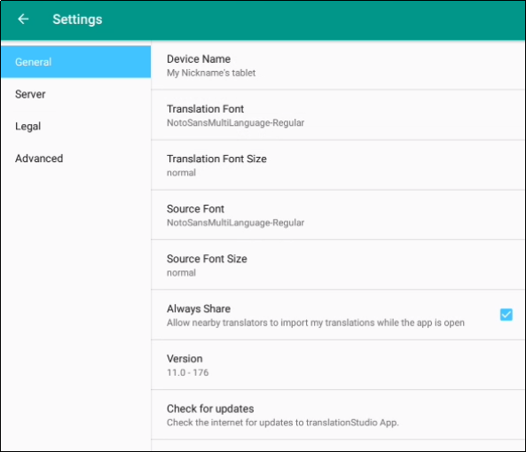

The General settings are as follows:

1. **Device name**
   1. Naming the tablet is helpful when sharing with a friend. See Uploading/Exporting Your Work for more information.
   2. Tap **Device name** to name the tablet. A pop-up window opens where you can enter a name for your tablet.
   3. Tap **OK** to save the name.  
      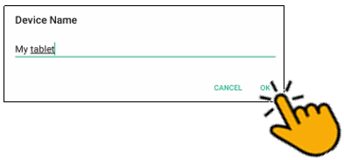
2. **Translation** **Font**
   1. The name of the chosen font is displayed. Tap **Translation Font** to change the displayed font in the text.
   2. A pop-up window shows the available fonts. Scroll through the names of the fonts and tap the name to select the desired font. When you have selected a font, the pop-up window disappears.  
        
      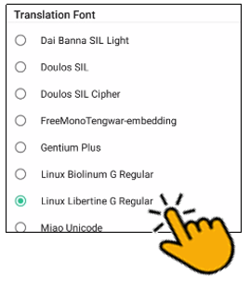
3. **Translation** **Font Size**
   1. The size of the chosen font is displayed. Tap **Translation Font size** to change the displayed font size in the text.
   2. ****A pop-up window shows the available sizes. Tap the desired size to select it. When you have selected a font size, the pop-up window disappears.  
      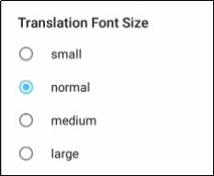

**NOTE**: When using non-alphabetic script, it is usually advisable to choose a large font size for readability.

1. **Source Font**
   1. The name of the chosen font is displayed.
   2. Tap **Source Font** to change the displayed font in the source.
   3. A pop-up window shows the available fonts. Scroll through the names of the fonts and tap the name to select the desired font. When you have selected a font, the pop-up window disappears.
2. **Source Font Size**
   1. The size of the chosen font is displayed.
   2. Tap **Source Font Size** to change the displayed font size in the text.
   3. A pop-up window shows the available sizes. Tap the desired size to select it. When you have selected a font size, the pop-up window disappears.
3. **Always Share**
   1. Tap in the empty square if you want the program to allow nearby translators to import your translations while the app is open.
   2. A blue square with a white check mark means that the option has already been chosen.
4. **Version**: The version of the BTT Writer program is displayed.
5. **Check for updates:** Tap to check for updates to BTT Writer. This uses an internet connection.

### Server Settings

Tap **Server** to view or change server settings.  
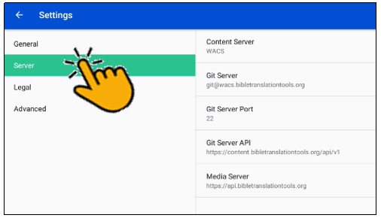

The server settings are as follows:

1. **Content Server**: By default, BTT Writer is set to upload to or import from the Wycliffe Associates Content Server (WACS). You can change this by tapping **Content Server** and changing the setting to DCS (for the Door43 Content Server.) When you change the Content Server setting, the settings shown below change automatically to the appropriate values for the selected server.
2. **Git Server**:

For WACS: git**@wacs**.bibletranslationtools.org

For DCS: git**@git**.door43.org

1. **Git Server Port**:

For WACS: 22

For DCS: 9299

1. **Git Server API**:

For WACS: https://content.bibletranslationtools.org/api/v1

For DCS: https://git.door43.org/api/v1

1. **Media Server**:

For WACS: https://api.bibletranslationtools.org  
For DCS: https://api.unfoldingword.orgLegal Settings

Tap **Legal** to view important legal information.   
  
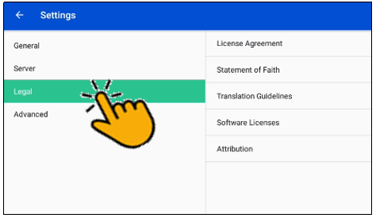

* **License Agreement** - read what you are permitted to do with the content in the program and the content that you create.
* **Statement of Faith** - you, the user of the program, agreed to this the first time the program was started. Read this to review what the Essentials Beliefs are.
* **Translation Guidelines** - read this document to learn about the guidelines that can help the translator clearly, accurately and naturally translate the text.
* **Software Licenses** - this file contains all the licenses for the various softwares that are used to create the BTT Writer program.
* **Attribution** - read this document to learn about the restrictions of using the derivative works and name branding.

### Advanced Settings

Tap **Advanced** to view or change the advanced settings.  
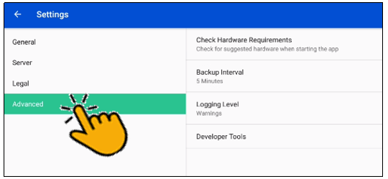

**Check Hardware Requirements**: Specify whether to check for suggested hardware when the app starts.

**Backup Interval**The program sets the backup to occur every 5 minutes. This can be changed by the end user.

* Tap the **Backup Interval** to open the option screen.

Tap the words to change the interval to '1 Minute', '5 Minutes', '10 Minutes' or to 'Disable Backup.' It is NOT recommended to disable the backup.  
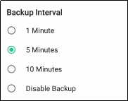

**Logging Level** and **Developer Tools**

The settings in these areas are set by the program. You should not change these settings unless directed to do so by a support technician.

## Updating Program Elements

Select Update from the Options menu on the Home page to see the options for updating program elements. You must be connected to the internet to exercise any of the update options.  
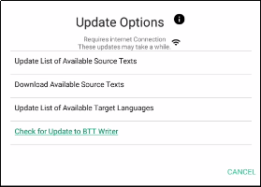

The options are:

* Update List of Available Source Texts
* Download Available Source Texts
* Update List of Available Target Languages
* Check for Updates to BTT Writer

### Updating List of Available Source Texts

To update the source text lists, select Update List of Available Source Texts from the Update menu.   
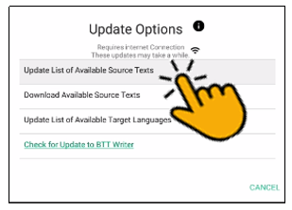

This process updates only the *list* of the available source texts, not the texts themselves. The purpose for downloading only the list of source texts is to reduce the number of files that would need to be downloaded. You will need to download a source text before using it.

Updating the list takes several minutes, so you need to wait for the process to complete.  
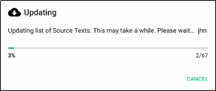

**Note**: You may receive a notice that the process is not complete; sometimes this notice is not accurate.

When the process is complete, the program notifies you of the number of new source texts that you can download. Tap **DISMISS** to close the window.  
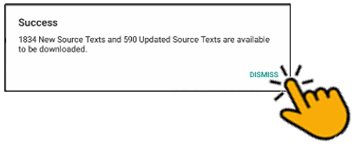

The program now presents you with choices to download selected source texts. If you don’t want to download now, tap outside the download window. If you do wish to download one or more source texts, the process is shown below.

### Downloading Available Source Texts

To download new source texts, tap Download Available Source Texts from the Update menu.  
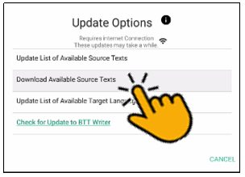

You have a choice to look at the source text lists in one of two ways:  


1. **By Language** – this choice enables you to download multiple books at once for a single language. If you choose to view by language and select a language, only the books that are available for that language are shown. Other books may become available as more source texts get translated and checked.
2. Scroll to the desired language or search by tapping the magnifying glass and typing the language name in the search box.  
   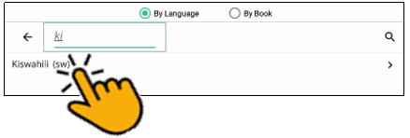
3. Tap the language to select it (if you tap a language by mistake, tap the back arrow next to the language to return to the language list.)
4. On the Choose Category list, tap to select a category. Some languages have more or fewer categories, depending on what source texts are available.  
   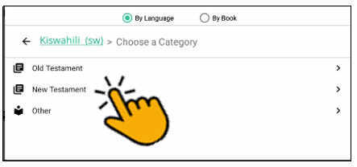
5. Tap the check box next to the source text(s) you wish to download, and then tap Download.  
   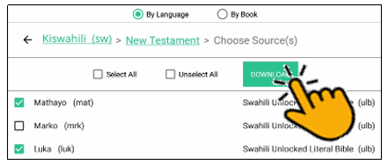
6. The selected text(s) download (this may take a few minutes) and then you should receive a success message. Tap **Close** to dismiss it.
7. The downloaded texts have a green check mark next to the name on the Source list.

**Note**: You may receive an unsuccessful message. One or more choices have a red x next to the name. This source text was not downloaded. You may try again to download the texts that were not successfully downloaded.



1. **By Book** – this choice enables you to download multiple languages at once for a single book. If you choose to view by book, only the languages for which that book is available are shown. Other books may become available as more source texts get translated and checked.
2. Tap to select a category. The possible categories are:  
   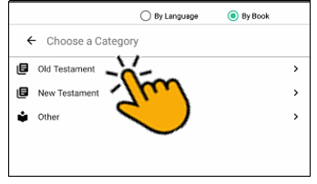 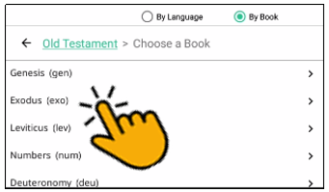
   1. Old Testament: Opens a list of Old Testament books
   2. New Testament: Opens a list of New Testament books
   3. Other
      1. Open Bible Stories
      2. translationWords
      3. translationWords OBS
3. Once you have selected a category, a list of available source texts opens. Select one or more source texts and tap Download.  
   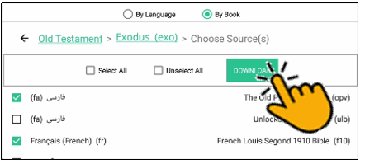
4. The selected text(s) download (this may take a few minutes) and then you should receive a success message. Tap **Close**.
5. The downloaded texts have a green check mark next to the name on the Source list.

**Note**: You may receive an unsuccessful message. One or more choices have a red **x** next to the name. This source text was not downloaded. You may try again to download the texts that were not successfully downloaded.

### Updating List of Available Target Languages

Tap Update List of Available Source Texts from the Update menu to update the list of all the target languages available in the program.  
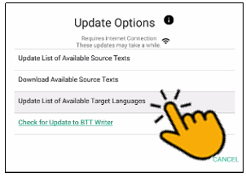

A progress window opens.  
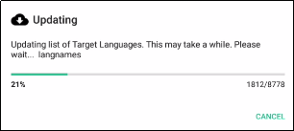

At the end of the process a message shows how many new target languages were added. Tap **CLOSE** to return to the Home screen.

### Checking for Updates to BTT Writer

Tap Check for Updates to BTT Writer from the Update menu to download any available updates to the BTT Writer program.  
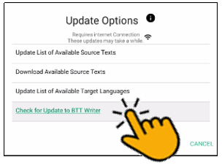

Unless you have a very old version of BTT Writer, there probably are no updates available.

## 